
American International University-Bangladesh (AIUB)
Department of Computer Science
Faculty of Science &Technology (FST)
Spring 21-22
Section: B
Software Quality Assurance and Testing
Student-Alumni Hub

A Report submitted
By

SN | Student Name | Student ID
1 | Md. Al Mamun Emon | 18-37860-2
2 | Syed Bisal Ahmed | 19-39584-1
3 | Dip Roy | 18-38628-2
4 | Md. Yousuf Afendi | 19-39887-1

Under the supervision of
ABHIJIT BHOWMIK

Software Test Plan

for

Student-Alumni Hub
Version 1.0 approved

Prepared by:

Md. Al Mamun Emon

Dip Roy

Md. Yousuf Afendi

Syed Bisal Ahmed

American International University Bangladesh
19 April,2022

Table of Contents
Prepared by: 2
Md. Al Mamun Emon 2
Dip Roy 2
Md. Yousuf Afendi 2
Syed Bisal Ahmed 2
Revision History 3
1. TEST PLAN IDENTIFIER:RS-MTP01.3 4
2. REFERENCES 4
3. INTRODUCTION 4
Background to the Problem 4
Solution to the Problem 5
4. REQUEIREMNT SPECIFICATION 5
4.1 System Features 5
4.2 System Quality Attributes 6
4.3 System Interface 7
4.4 Project Requirements 8
5. FEATURES NOT TO BE TESTED 10
6. TESTING APPROACH 10
6.1 Testing Levels 10
6.2 Test Tools 11
6.3 Meetings 14
7. TEST CASES/TEST ITEMS 14
8. ITEM PASS/FAIL CRITERIA 17
9. TEST DELIVERABLES 17
10. STAFFING AND TRAINING NEEDS 18
11. RESPONSIBILITIES 18
12. TESTING SCHEDULE 18
13. PLANNING RISKS AND CONTINGENCIES 19

Revision History
Revision | Date | Updated by | Update Comments
0.1 | 02.04.2022 | Md. Yousuf Afendi | First Draft
0.2 | 03.04.2022 | Syed Bisal Ahmed | Second Draft
0.3 | 07.04.2022 | Dip Roy | Third Draft
0.4 | 10.04.2022 | Md. Al Mamun Emon | Fourth Draft
0.5 | 11.04.2022 | Dip Roy | Fifth Draft
0.6 | 13.04.2022 | Syed Bisal Ahmed | Sixth Draft
0.7 | 16.04.2022 | Md. Yousuf Afendi | Seventh Draft
0.8 | 18.04.2022 | Md. Al Mamun Emon | Eighth Draft
1.0 | 19.04.2022 | Emon, Bisal, Yousuf, Dip | Final Draft

TEST PLAN IDENTIFIER:RS-MTP01.3

REFERENCES
System Interface : draw.io [https://app.diagrams.net/?libs=general;flowchart]
Testing tools : embunit [https://www.embunit.com]
Tessy [https://tessy.com]
Jira [https://www.atlassian.com/software/jira]
Scheduling : Microsoft Excel.

INTRODUCTION

Background to the Problem
Nowadays it is very important to have communication with each other. Students and Alumni are an asset for any university. Therefore, it is really crucial for the students to be guided by the alumni as they are like more experienced in both educational and professional carrier. Various communication system of student and alumni management are present out there but there any not too many. Moreover, these kinds of platforms are not authorized by the officials of any university. Mostly the type of systems those are available in universities of our country, like the portal of our university, but at the end of the day, those are basically a course management platform. The portal of our university does not provide any facilities for the alumni to connect with the juniors.
At present time, just after the Covid-19 situation, most of the universities started conducting most of their activities through some online platforms i.e., Google Classroom, Microsoft Teams, Zoom etc. which are mainly providing the communication between faculties and students for curricular activities. Hence it is not the ideal platform for students to be in touch with the alumni as it doesn’t involve them. There are some social platforms like Facebook and LinkedIn but it is really hard to find the persons who are recently graduated from the same university those he actually wants to follow. That’s why it is necessary to be considerate about this problem.

Solution to the Problem
To deal with the problem mentioned above, we want to present a solution, a platform to computerize the communication system between students and alumni or even faculties by developing a web application which is user friendly, simple, fast and cost-effective.
That’s when “Student-Alumni Hub” comes to light. The system will be functional for any kind university so that connection between educational institute and students remain the same even after graduation and it will be very beneficial for students because it will help them to reach out to their faculties and alumni anytime without hassle for any kind of official as well as non-official queries.
It deals with the admin, student, faculty, alumni information and also to contact with different user through chatting and much more features. The main function of the system is to log in and register user and user information, to check user information, purchase or enroll course, uploading research paper through this website. Traditionally, it was done manually. Our main focus is to design a unique and interactive portal that will improve experience for students, alumni and faculties of any educational institution. The whole system will through the help of internet.
As for business objective, the website will have a good demand for the universities and also for the students. So, we will try to develop the website in such a way that it can be delivered as a packaged solution. It can be used by other educational institutes as out-of-the-box, configured, integrated or even as an extended solution. There is also a feature for enrolling in different types of courses provided by alumni. And every time a transaction takes place, a particular percentage will be deducted from the course fee as per contract with our company.
There are some companies that provide software for this kind of problem such as Almabase or Alumni Channel etc. But this is not a available practice in our country.

REQUEIREMNT SPECIFICATION

System Features
System is an entity that actually performs any function. The features are provided by the system so that it can take input from the user and can provide the proper output. The system features can be categorized into 2 types. The functional requirement describes the service that the program must provide.
Functional Requirements:
- Registration: The first and foremost thing that a user must do is registration. A user will be able to join the site as a member. A user need register in order to search for other users and perform tasks, but no in order to see the events that have already been made.

- Login: A user who has already registered may use the features and ability to perform intended task by logging in using their email and password.

- Update Profile: The currently logged-in user desires to make changes to their user profile information.

- Logout: The previously logged-in user will be able to log out of the website.

- Forgot Password: The user has forgotten their password and requires assistance in resetting it. The system must confirm the users identify before granting them access to their password.

- Search: The logged in user can look for alumni or student or any kind of event or courses.

- CV submission: Registered students can submit their CV’s which can be found by the alumni if they are looking for interns.

- Pin Events: Any types of users can pin any important events and also can set reminders.

- Course Offer: After proper verification, alumni can post ads for their course in the feed. Users can enroll into courses.

- Course Evaluation: There will be a rating system which will collect feedbacks from the users who enrolled in courses to evaluate the course outcome.
- Paper adding: Alumni can add their research domain and also can post their research works. They can also look for students for collaborating with their research.

- Chatting: Users can communicate with each other through message.

- Following: Each user can follow another user of their liking. A notification system will be there to notify them about any happenings related to those follows.

- Create/Modify/Delete post: Alumni can create/modify post for job offer and can also delete them whenever they want.

- 24/7 Online support: Online system support department will be there to handle all types of user queries.

System Quality Attributes
Another type is the non-functional requirement. It is the system qualities as security, reliability, performance, maintainability, scalability, and usability. They act as limits or limitations on the system’s architecture across the various backlogs.
Non-functional Requirements:

- Privacy: We’ll have to keep it in mind, as our system will store many private information, we must provide proper privacy to all the users data. So, all the information must be stored in the private cloud storage of the organization

- Availability: Our “Student Alumni Hub” is internet based and it should be available anywhere anytime. This type of system will be available for access not only on the campus, but also outside of the campus. It would guarantee a permanent service of 24/7 with the use of redundant system to avoid net traffic overflow.

- Scalability: As our first startup, the resources that will be available to us, can be short. So, it could be still weak on scalability at the infrastructure level. On the public cloud, several resources could be deployed and assigned just for a specific duration when receiving usage of the website is very high. Somehow, we have to build it in such way in which it will be able to add/delete resources when required.

- Usability: The interface of our “Student Alumni Hub” will be user-friendly and will also support adaptiveness and personalization. Based on user’s preference, user interface is going to change and generate recommendation to guide the user through the site.

- Performance: The website response time should be fast. Improvements can be done by upgrading the web hosting plan, enabling leverage browser caching, enabling GZIP compression, reducing HTTP requests, optimizing images and database and so on.

- Security: We have to keep all the information in the database confidential and as the data is distributed on different servers on the cloud, data is out of the control of the user. So, we have to provide strong security so that any kind of fraudulent incident cannot take place.

These requirements will be updated according to the needs of the users, so that they can use this platform with full faith.

System Interface
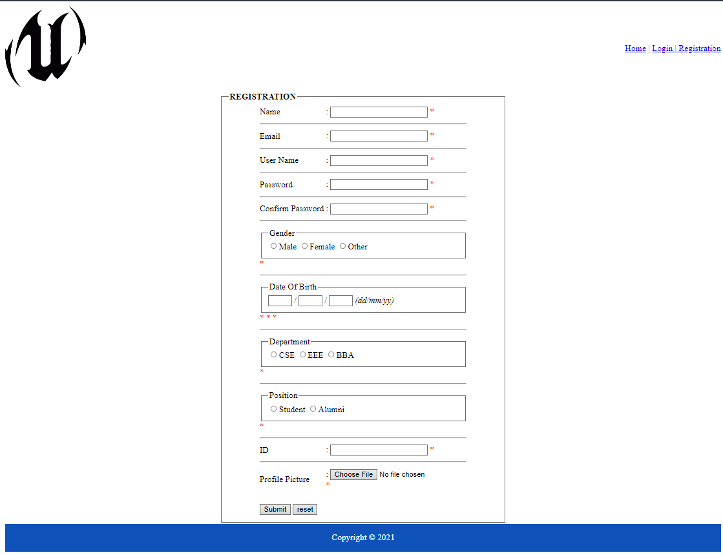
Fig1:Registration Interface
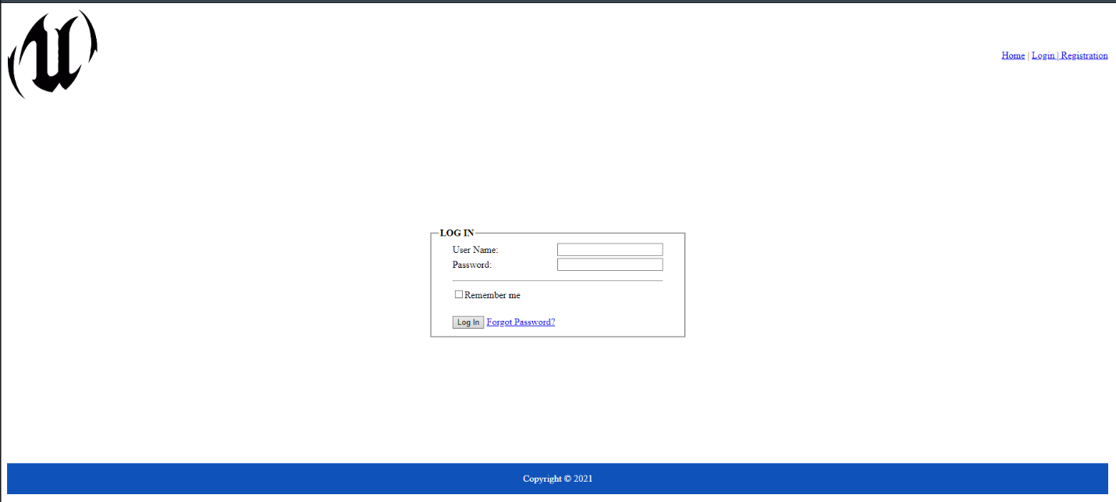
Fig2:Login Interface
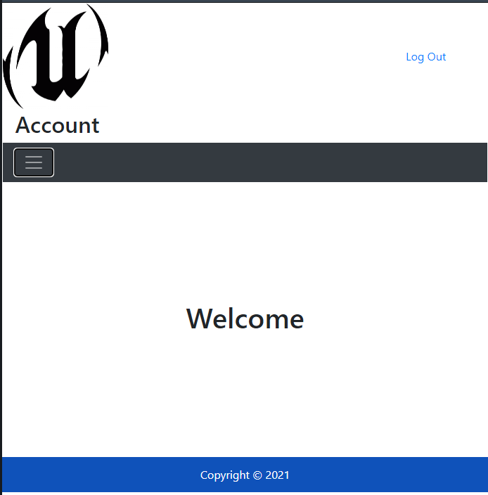
Fig3:Welcome Interface
Fig4: Use Case Diagram of “Student-Alumni Hub”

Use case Diagram Description: In UML, use-case diagrams model the actions of a system and help to capture the conditions of the system. Use-case diagrams describe the high- level functions and scope of a system. In use case diagram, we show how users are connected to the system.
Fig5: ER Diagram of “Student-Alumni Hub”

ER Diagram Description: ER diagram is necessary for modeling the data stored in a database. It's the basic design to build a database. ER diagrams define what data we will store the entities and their attributes. It’s also show how entities relate to other entities.

Project Requirements
Effort Estimation
Coefficient=2.4 [as the project type is organic]
We assume the SLOC of our project=14000
Project Complexity, P=1.05 [as the project type is organic]

Effort = Coefficient*(SLOC/1000)P
=2.4*(14000/1000)1.05
=38.34
PM=38.34
T=0.38

Duration time in weeks for project, DM=2.50*(PM)^{T}
=2.50*(38.34)^{0.38}
=9.993 = 10

Required number of people = ST (average staffing necessary)
= PM/DM
= (38.34/ 10)
= 3.84 = 4
Budget Estimation
Duration=10 weeks=70 days=2.5 Month
Working Days = 5 days a week.
= 5*10=50 days=50*8=400 hours.

Salary=1500/- (per hour)
Salary=160*1500 [As 160 hrs. in 1 month]
=240,000/-(monthly)

Total Salary for Project =240,000*2.5=600000/-
For One Developer =600000/4=150000/-

Utilities Bill =15000*2.5=37500/-
Office rent= 30000*2.5=75000/-
Transportation Cost for employees(per-month) = 6000*2.5=15000/-
Instrument Cost =50000/-
Maintenance Hour per month 15 hr and cost 2500/= per hour
Maintenance cost= 2500*15*6=225000/-
Criteria | Amount (Taka)
Total Salary | 600000/-
Utility Bills | 37500/-
Office Rent | 75000/-
Transportation Cost | 15000/-
Instrument Cost | 50000/-
Maintenance Cost | 225000/-
Total Cost | 1002500/-

Total Cost 1002500/-
We assume 20% of total cost as profit
Total Amount to be paid = (1002500 + 1002500*20%)
= 1203000/-

FEATURES NOT TO BE TESTED
The following is a list of the areas that will not be specifically addressed. All testing in these areas will be indirect as a result of other testing efforts. For example:
- User ID and Password of each user should not be given to the tester.
- Communication between two users won’t be tested by tester.
- The tester will test if any transaction is successful or not. They won’t test the process of how the transaction system works.
- Editing profile is not a major module to check.
- Uploading a file doesn’t require tested by a tester.

TESTING APPROACH

Testing Levels
As for the software, the testing process consists of Unit Testing, System Testing and Acceptance Testing.

Unit Testing: UNIT testing is a type of testing in which individual units or functions of software testing. Its primary purpose is to test each unit or function. A unit is the smallest testable part of an application. It mainly has one or a few inputs and produces a single output. In procedural programming, a unit referred to as an individual program, while object-oriented programming languages include Base/Superclass, abstract class, Derived/Child class takes place. Unit test frameworks, drivers, stubs and mocks /fake objects used in Unit Testing. It works on the basis of a White box technique. With Unit Testing Enterprises can -
- Improve Quality of Code
- Build Reusable and Reliable Code
- Simplify Documentation
- Enable Seamless Integration

System and integration testing: System and integration testing is done by the developer team and test manager. After completing the integration testing, System testing is done. Integration testing is a combination of both black box and white box testing. Integration testing is conducted incrementally as a series of test cycles. When a developer fixed all the defects one cycle completes and moves to the next cycle. in this testing approach, defects are found early.

System testing is done after the integration testing. It uses a black box testing approach and is done by independent users. Beta testing is a part of system testing. In System Testing, Defect removal efficiency, defect age and defect spoilage metric is calculated. Other testing like stress, load security, and performance testing are also done here.

Acceptance Testing: Acceptance Testing is a technique for determining whether or not a software system meets the requirements specifications. The major goal of this method is to check if the system complies with business needs and if it meets the requirements for distribution to end users. Acceptance testing will be carried out by the project's real end users or clients, with the help of the test manager and development team leader.

Test Tools

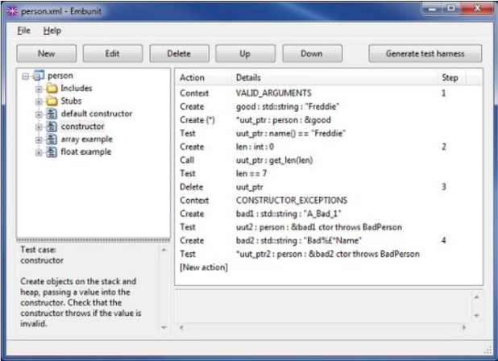
- UNIT TESTING: Embunit is a unit testing tool for programmers and tester developing software in C or C++. It is aimed at embedded software development, but can be used to create unit test for any software in Written in C or C++. Embunit eliminates the mundane, repetitive aspects of writing unit tests, leaving free to concentrate in defining the test behavior. This is achieved by specifying a sequence of actions. Embunit generates the unit test source code automatically. Embunit has been developed with flexibility in mind, and can be customized to creator. Unit test for virtually any hardware platform; even the smallest microcontrollers. Embunit apart from unit testing framework is that we don't need to write any code. Tests are specified as a list of actions, and the source code is generated automatically. We only have to write code if we need to stub something out, in which case Embunit has a handy “context mechanism so our stub code always knows what’s going on.

Fig6: Interface of Embunit

- SYSTEM/ INTEGRATION TESTING: Integration testing tools are used to test the interface between modules and find the bugs; these bugs may happen because of the multiple modules integration. The main objective of these tools is to make sure that the specific modules are working as per the client's needs. One of them It is TESSY It is an essential tool for integration testing that is used to execute the integration and unit testing for the embedded software. It will take care of the whole test organization along with the requirements, traceability, test management and the coverage measurements. The three primary functions of TESSY are TIE(test interface editor), TDE(test data Editor) and workspace. It is used to analyze the interface to the function and defines the variable used by that function. For the test execution results , it creates the test report.
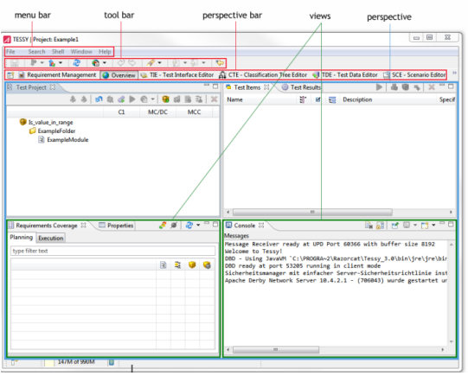

Fig7: Interface of TESSY

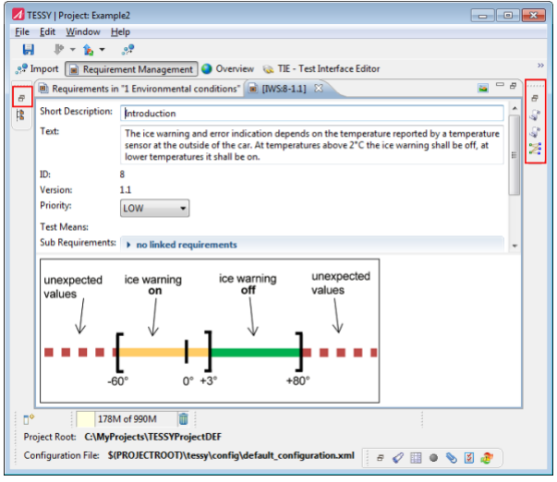

Fig8: Interface of TESSY

- ACCEPTANCE TESTING : JIRA is a tool developed by Australian Company Atlassian. This software is used for bug tracking, issue tracking, and project management. First , We create a project in jira.Then, Add team members by sending them request through email.After that we create a issue then assign the issue in the sprint to allocate project time assign specific task to each group member. We create a deshboard to see the progress of our project.
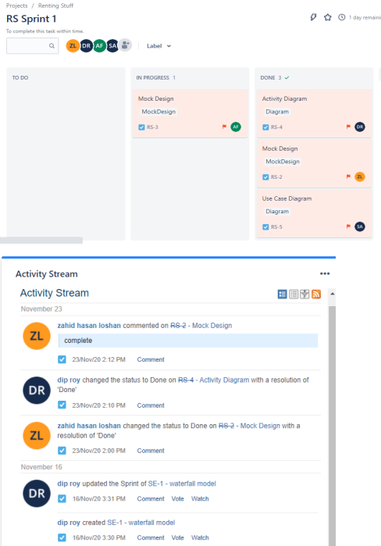

Fig9: Interface of JIRA

Meetings
The test team has done a meeting after every one or two weeks. Extra two weeks are being allocated for emergency purposes. The main purpose of the meeting was to evaluate the progress of the project. Also identifying the bugs and defects as early as possible. Also, a major part of the meeting was to ensure that the project fulfilled the customer's requirements.

We have done some important task-oriented meetings in the last two weeks. We a done this meeting through an application called Microsoft Teams. These meetings have been started on 13-April-2022 and ended
in 19-April-2022.

TEST CASES/TEST ITEMS
Tast Case 1
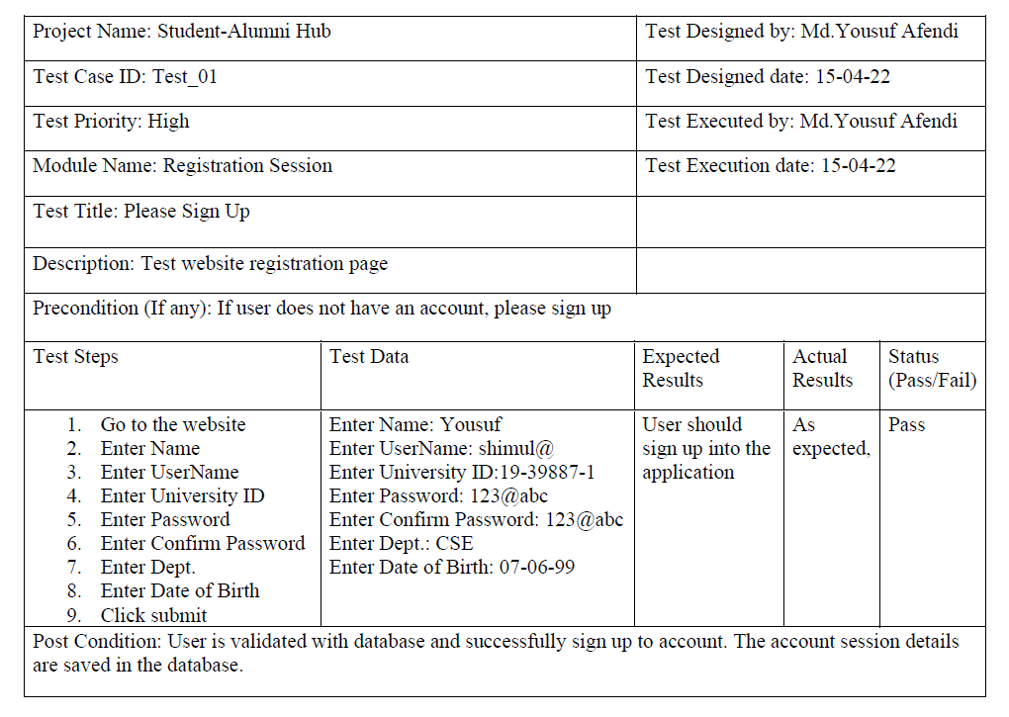
Tast Case 2 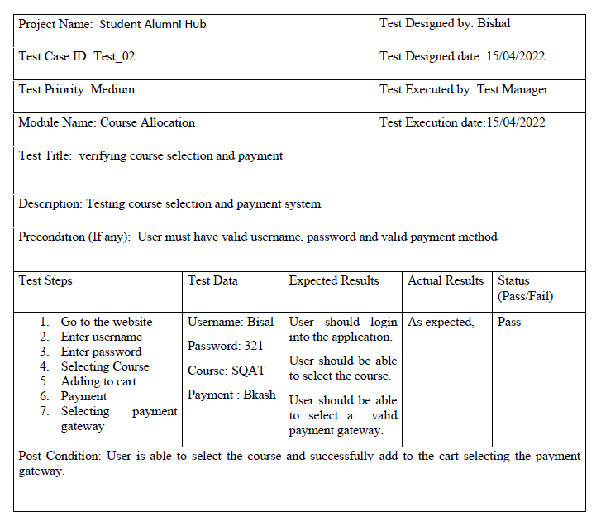
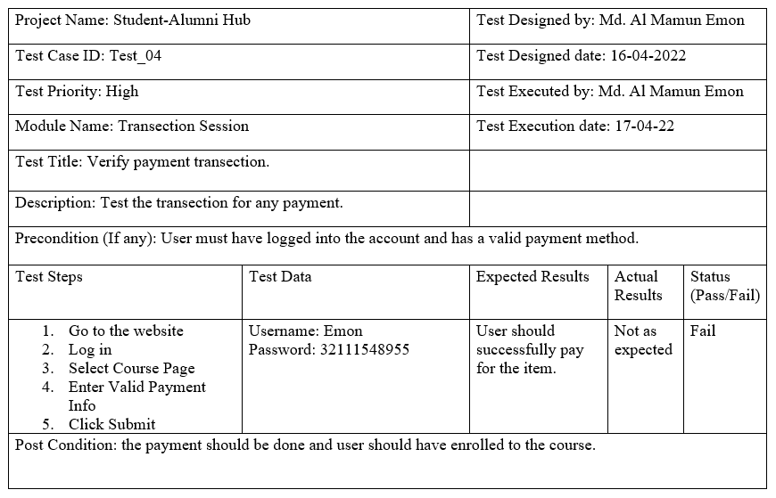
Tast Case 3
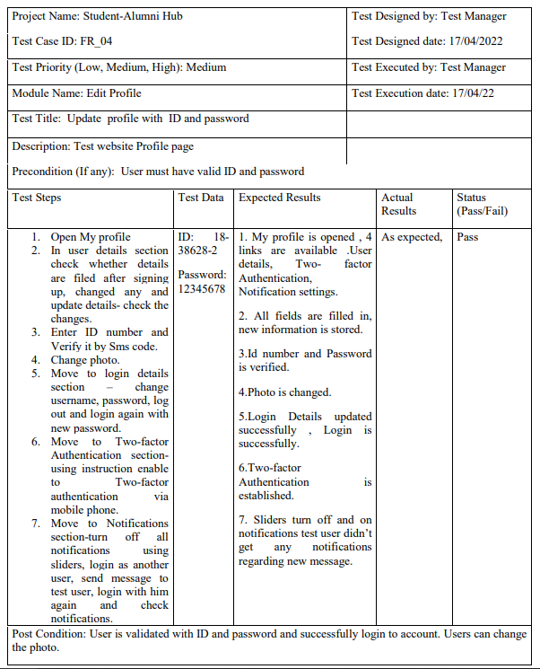
Tast Case 4

ITEM PASS/FAIL CRITERIA
Unit Testing: Pass/ Fail Criteria will be estimated by many ways and they're given below
Testing Procedure, the team will be doing the following tasks-
1. There will be error free codes and in time compilation
2. The test will pass only if there's 100 passing rates.
3. If any error found or passing rate remains below 100 it'll be resolved in time.
4. The limit of minor defects is< = 25
5. All the possible tests will be proved

Testing Details: The pass/ fail criteria for unit tests are very straightforward and will be determined by Junit testing framework. After the execution of our unit test suite, JUnit will mark each individual unit test indicating whether it passed or failed according to our assert statements. The entirety of our unit testing will be considered complete once all test cases pass successfully, and we've achieved at least 70 code coverage.

Acceptance Testing: Pass/ Fail Criteria will be estimated by many ways and they're given below
Testing Procedure, the team will be doing the following tasks-
1. Initially all the test results will be marked as ‘Fail’.
2. If the Project Sponsor reviews and implements the test the test result will be marked as ‘Pass’.
3. If any error found or passing rate remains below 100 it'll be resolved in time.
4. Development team will also view this process
5. All the possible tests will be proved

Testing Details: For acceptance testing, each of our conditions from our Conditions Document will initially be marked as “Fail”. Once the project sponsors have reviewed the application for a particular requirement, if that requirement has been successfully implemented, also that requirement will be marked as “Pass”. This process will also be followed by the development team for earlier testing; however, features aren't officially accepted until noted by the sponsors.

TEST DELIVERABLES

Test specification document: The summary of the scripts that are going to be tested
• Test Plan: The design carries testing process, sequence.
• Test Strategy: The high- level document defines the testing approach defined by Test Lead
• Test Script :To ensure every process flow is tested completely.
• Test Designs: Formally defined way to ensure design of test.
• Test Cases: Enlists various combination of input and output to decide farther rectification
• Test Logs: Complete list of series of test execution activities and running the tests.
• Bug report: Defect report of a element
• Test Summary: Report Summary of testing. Overall opinions, probabilities of test pass/ Fail
• Test data: The data or input provided to the operation with intent of costing results.
• Test Status report: Track the progress of the operation.
• Test Scripts: To Define way and instructions for the test team that will insure validation of functionality.

STAFFING AND TRAINING NEEDS

It is preferred that there will be four testing members and at least two (2) full time tester assigned to the project for the system/integration and acceptance testing phases of the project. All members will have four (4) weeks for training and approximately ten (10) weeks into the project they would be assigned full time. If a separate test person is not available the project manager/test manager will assume this role.

In unit testing, system testing and acceptance testing, we use EMBUNIT, TESSY,JIRA. We need to have a good knowledge of these software.

RESPONSIBILITIES
The system/integration test documentation & execution part is done by Bisal Ahmed. Unit test documentation & execution is done by Yousuf. Acceptance test documentation & execution is done by Dip. System design reviews and detailed design reviews are done by Emon. Test procedures and rules, screen & report prototype reviews are done by Yousuf and Bisal. Change control and regression testing is done by Emon and Dip.

TESTING SCHEDULE
Time has been allocated within the project plan for the following testing activities. The specific dates and weeks for each activity are defined in the project plan timeline. The persons required for each process are detailed in the project timeline and plan as well.
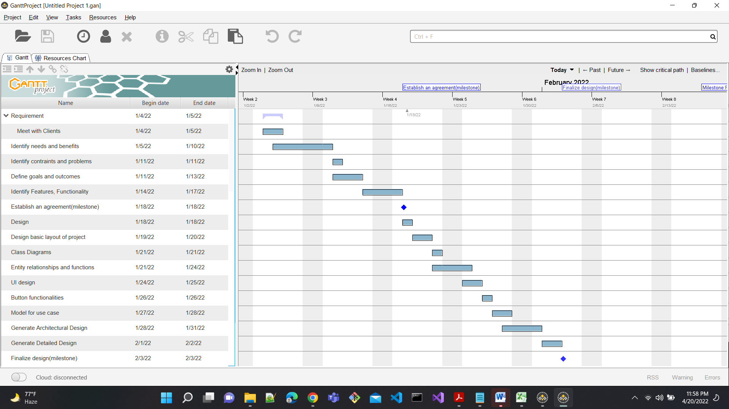
Fig10:Gantt Chart

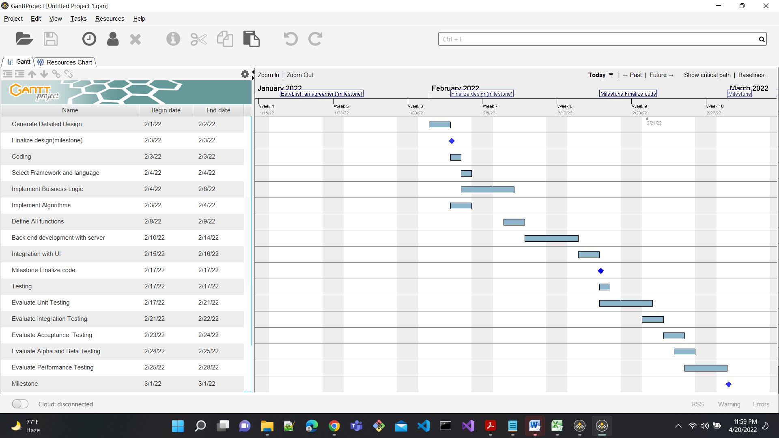
Fig11:Gantt Chart

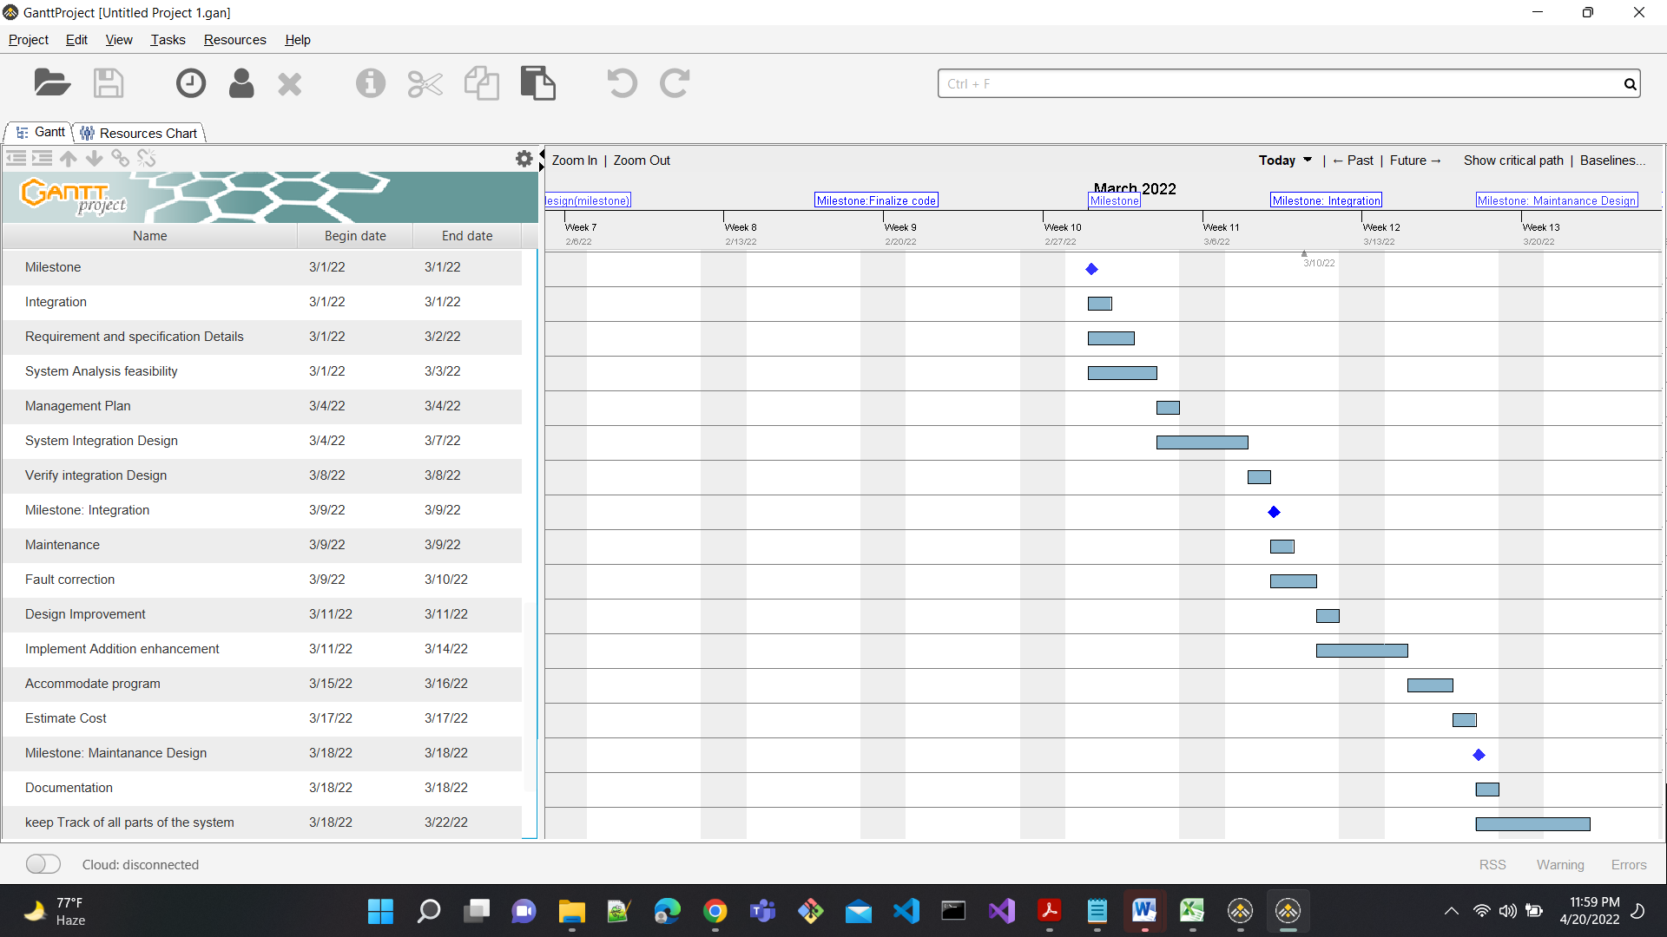
Fig12:Gantt Chart

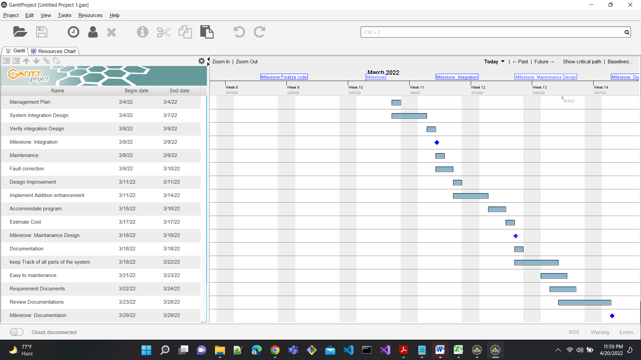
Fig13:Gantt Chart

PLANNING RISKS AND CONTINGENCIES
There is a limited staff in our testing team. Because of the staff shortage, there may be delays in the staff review. Also, there may be some delays in reviewing the documents and participating in the acceptance testing process. As accepting testing requires client’s interaction at some point, it is a very challenging matter to convince the client. There will be no attempt to bypass any part of the review and testing processes for these reasons.

14. REFERENCES
System Interface : draw.io [https://app.diagrams.net/?libs=general;flowchart]
Testing tools : embunit [https://www.embunit.com]
Tessy [https://tessy.com]
Jira [https://www.atlassian.com/software/jira]
Scheduling : Gantt Project Software

